電通二乙微處理器實驗 實驗結報

實驗名稱 | Lab01
組別 |  | 組員 | 03053622 易大閎

- 實驗目的
讓LED做出閃爍以及SOS信號。

- 實驗步驟
略
- 程式碼
Check 1 :

void setup()
{
pinMode(13, OUTPUT);
}

void loop()
{
digitalWrite(13, HIGH);
delay(1000); // Wait for 1000 millisecond(s)
digitalWrite(13, LOW);
delay(1000); // Wait for 1000 millisecond(s)
}

Check 2 :

void setup()
{
pinMode(13, OUTPUT);
}

void loop()
{
digitalWrite(13, HIGH);
delay(100); // Wait for 1000 millisecond(s)
digitalWrite(13, LOW);
delay(100); // Wait for 1000 millisecond(s)
digitalWrite(13, HIGH);
delay(100); // Wait for 1000 millisecond(s)
digitalWrite(13, LOW);
delay(100); // Wait for 1000 millisecond(s)
digitalWrite(13, HIGH);
delay(100); // Wait for 1000 millisecond(s)
digitalWrite(13, LOW);
delay(100); // Wait for 1000 millisecond(s) -S
digitalWrite(13, HIGH);
delay(300); // Wait for 1000 millisecond(s)
digitalWrite(13, LOW);
delay(100); // Wait for 1000 millisecond(s)
digitalWrite(13, HIGH);
delay(300); // Wait for 1000 millisecond(s)
digitalWrite(13, LOW);
delay(100); // Wait for 1000 millisecond(s)
digitalWrite(13, HIGH);
delay(300); // Wait for 1000 millisecond(s)
digitalWrite(13, LOW);
delay(100); // Wait for 1000 millisecond(s) -O
digitalWrite(13, HIGH);
delay(100); // Wait for 1000 millisecond(s)
digitalWrite(13, LOW);
delay(100); // Wait for 1000 millisecond(s)
digitalWrite(13, HIGH);
delay(100); // Wait for 1000 millisecond(s)
digitalWrite(13, LOW);
delay(100); // Wait for 1000 millisecond(s)
digitalWrite(13, HIGH);
delay(100); // Wait for 1000 millisecond(s)
digitalWrite(13, LOW);
delay(300); // Wait for 1000 millisecond(s) -S
}

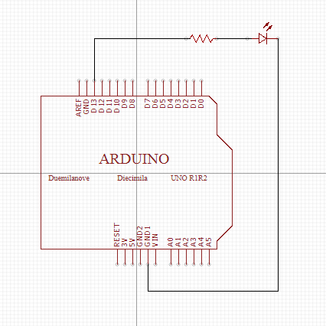
- 實驗結果及分析
實驗成功

- 心得討論
繪圖程式不好找阿，只好線上找另一個了，這個還不錯用。
- 修正電路圖
- 修正程式碼

